**Predictive maintenance for a water supplier: Internet of things**

Trinoy Saha

# Introduction and Overview

Data-Driven Optimization for City Water Supply

**Introduction:**

* Welcome to our project initiative aimed at revolutionizing the city's water supply management through data-driven strategies.

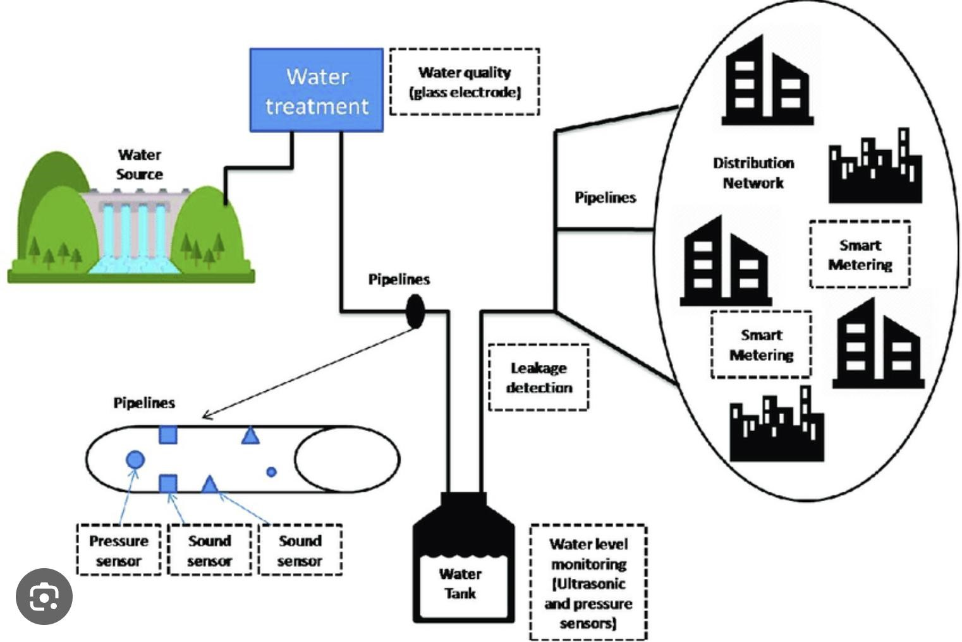

**Water**

**Source**

**Pipelines**

**Pipelines**

**Pipelines**

Water

treatment

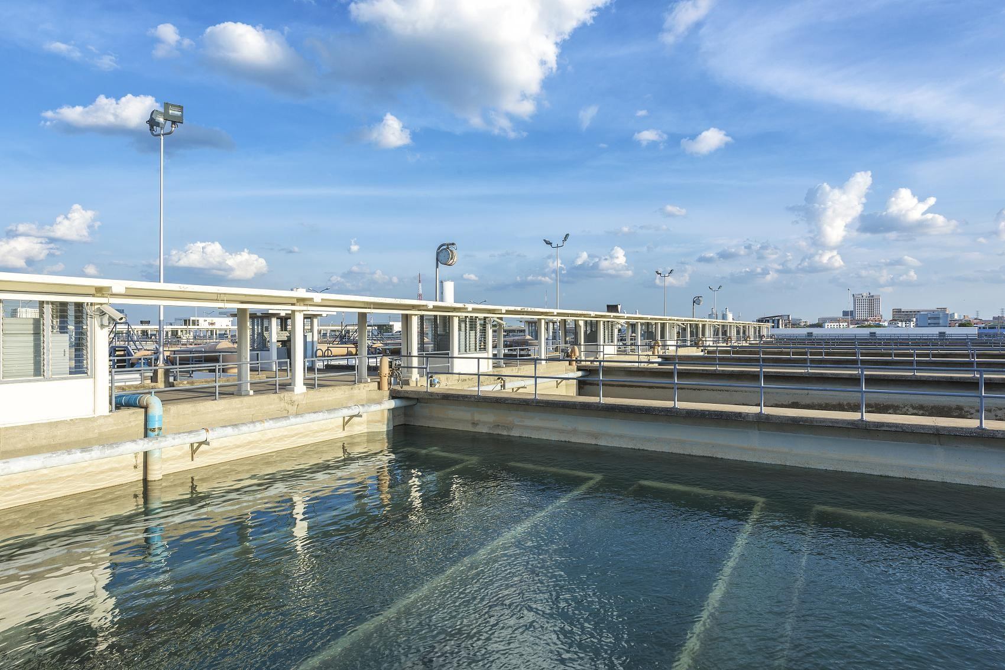

* Our goal is to enhance the efficiency, reliability, and safety of water delivery to every resident.

**Project Objective:**

* Implementing a comprehensive data collection and analysis framework to optimize control and maintenance operations.
* Ensuring sustainable water management aligning with environmental standards and urban needs.

**Significance of Data in Water Supply Management:**

* Data plays a crucial role in modernizing water supply systems, offering insights into usage patterns, system performance, and maintenance needs.
* It enables us to predict and prevent issues, ensuring uninterrupted, quality water supply.

# Data Definition and Sources

**Data Definition:**

* Flow Rate Data: Measures the volume of water flowing through the system per unit time.

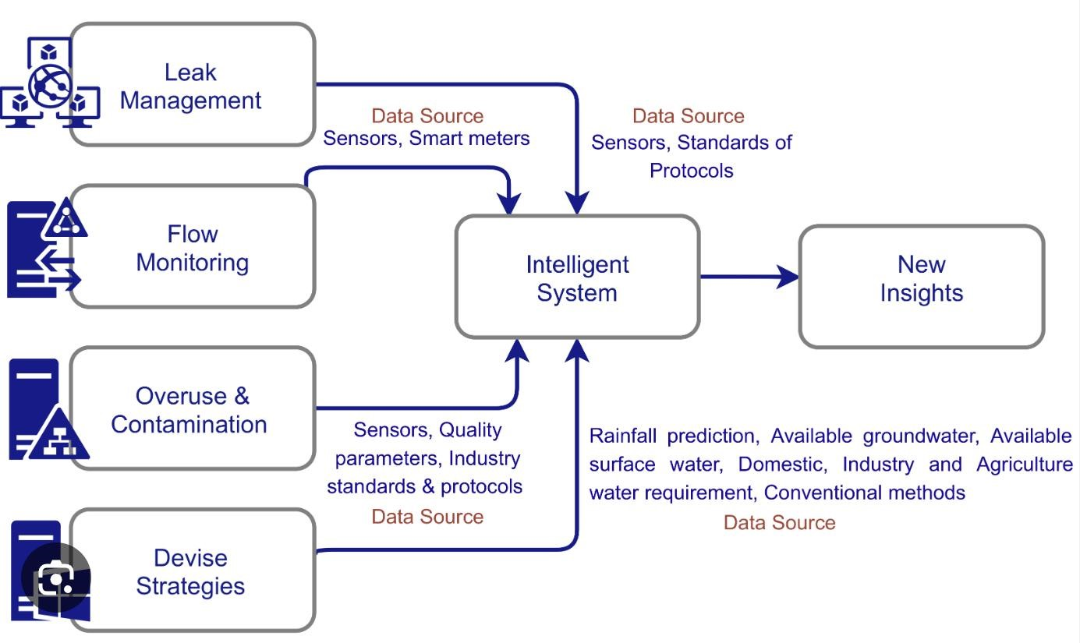

Maintenance

Logs

* Pressure Readings: Monitors the pressure within pipes to identify potential leaks or weak points.
* Water Quality Indicators: Includes pH levels, contaminant presence to ensure safety and compliance with health standards.
* Maintenance Logs: Detailed records of repairs, replacements, and inspections of the water supply infrastructure.

**Data Sources:**

* Flow Rate and Pressure: Collected using IoT sensors installed at critical junctures throughout the water distribution network.
* Water Quality: Data gathered from automated sensors at treatment facilities and periodic manual sampling points.
* Maintenance Logs: Compiled from operational databases and field reports submitted by maintenance crews.

# Data Usage and Value

|  |  |  |
| --- | --- | --- |
| **Data Usage:**   * **Predictive Maintenance**: Utilizing flow rate, pressure readings, and maintenance logs to foresee and address potential system failures. * **Water Quality Management**: Continuously monitoring water quality indicators to ensure compliance and immediately address contamination. * **Demand Forecasting**: Analyzing usage patterns to predict demand and optimize resource allocation. |  | **Data Value:**   * **Flow Rate and Pressure Data**: Value Rating - 4/5. Crucial for maintaining system integrity and preventing leakages. * **Water Quality Indicators**: Value Rating - 5/5. Paramount for public health and regulatory compliance. * **Maintenance Logs**: Value Rating - 4/5. Essential for costeffective and proactive infrastructure management. |

# Data Availability and Priority

|  |  |  |
| --- | --- | --- |
| **Data Availability Assessment:**   * Flow Rate and Pressure: Availability Rating - 4/5. Widely accessible through IoT sensor integration. * Water Quality Indicators: Availability Rating - 3/5. Requires a mix of automated sensors and manual sampling. * Maintenance Logs: Availability Rating - 4/5. Readily available from existing operational databases and field reports. |  | **Data Priority:**   * Immediate Actions: Install additional IoT sensors for real-time flow and pressure data. Enhance data integration from existing maintenance logs. * Short-term Goals: Improve water quality monitoring with a combination of sensor upgrades and more frequent sampling. * Long-term Strategy: Develop comprehensive data analytics capabilities for predictive maintenance and demand forecasting. |

# Innovation and Expected Value

|  |  |  |
| --- | --- | --- |
| **Innovative Use Cases:**   * AI-Driven Leak Detection: Harnessing predictive analytics to identify and address leaks before they escalate. * Real-Time Water Quality Monitoring: Implementing advanced sensor technology for continuous assessment and instant alerts. * Smart Demand Management: Using data insights to optimize water distribution based on usage patterns and forecasted demand. |  | **Expected Value of Innovations:**   * Enhanced Operational Efficiency: Reduced costs and improved response times through predictive maintenance. * Public Health and Safety: Ensuring consistently high water quality and rapid response to potential hazards. * Sustainable Resource Management: Balancing supply and demand effectively to support environmental sustainability. |